Write one sentence to remind you of your goal here

Put your chart title here

Charts were made with various unit numbers, but you can change these numbers on your table to fit with what you are measuring.

Put the start date here

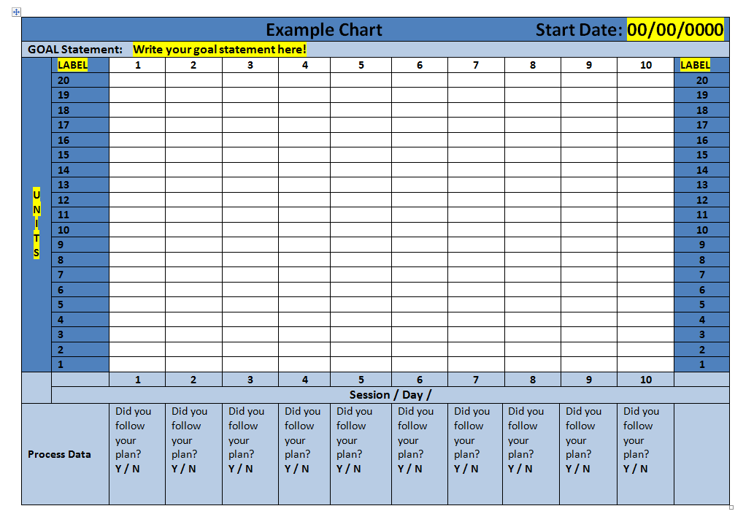

Label the horizontal axis with a unit of time

Answer this question for each time you collect data.

Describe the units that you are measuring. (Example: number of times talking out of turn, times room was clean)