Strategic Planning Worksheet
- We became familiar with the fundamental aspects of creating a good plan on the “Planning” page.

- “Strategies Page”
  - On the “strategies” page, we selected one of the areas of concern from the strategy table. Our area of concern is __________________________________.
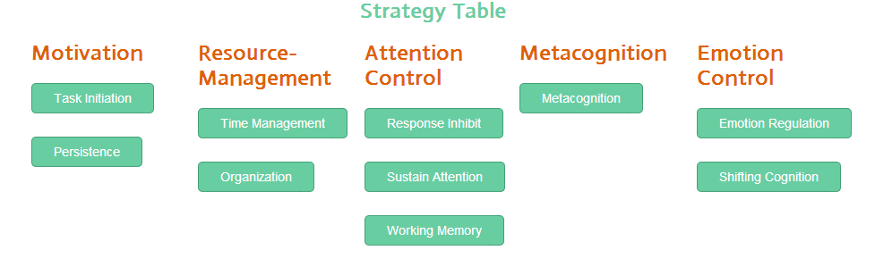
  - Upon selecting an area of concern, you are brought to a page of resources that may be helpful for in targeting this area of concern.

  - Using the Weebly website or another resource we selected the following
strategy (ies) to address our area of concern.
    - ______________________________________________
    - ______________________________________________

- When, where, why, who and how are we going to implement the strategy(ies)?
When – When will this strategy be used?
Where – Where will this strategy be used?
Why – Why is this strategy going to be used?
Who – Who is responsible for implementing this strategy
How – Describe the strategy so that anyone who reads this will understand exactly how to use the strategy. Do we want to adjust or customize any parts of the strategy to fit better with us?

Strategy 1. When:_________________________________________________________Where: ________________________________________________________
Why: _________________________________________________________
Who: _________________________________________________________
How:__________________________________________________________ _______________________________________________________________
_______________________________________________________________

Strategy 2. __________________________________________________________
When:_________________________________________________________ Where: ________________________________________________________
Why: _________________________________________________________
Who: _________________________________________________________
How:__________________________________________________________ ______________________________________________________________________________________________________________________________

